Tomasz Matuszczak
7300-41812

Utilizing the property temporal coherence, I have created an encoder in python that transforms the provided video data into a different model that has significantly lower source entropy and therefore can achieve much better compression than the original source model. The transformation consists of taking the diff of a pixel's values between frames, with the first frame of the original being encoded as the diff from a blank (all pixel values are 0) frame.

This effectively changes the data from a symbol set of in values from 0-255 into a symbol set of values from 0-510, with 255 representing a diff of 0, values below 255 representing a decrease in a pixel's value, and above representing and increase.

To see if this transformation is an improvement, we first calculate the source entropy, which is computed to be 6.92. Next we apply the transformation and calculate the entropy of the new model data, which comes out to be 4.25. This is a dramatic improvement, and since the arithmetic encoder can encode at entropy, we are guaranteed better compression. Furthermore, if we look at the distribution of symbols in our symbol set between the two encodings, we get further evidence that the new model is better:

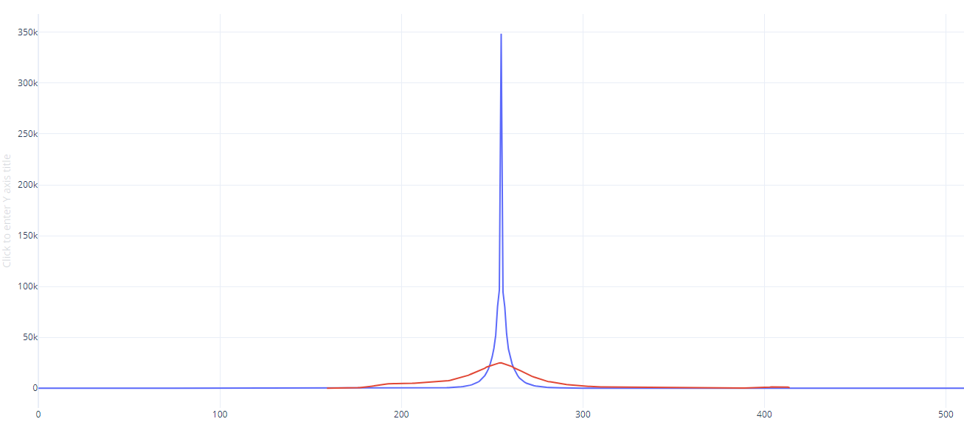
The above graph has total number of occurrences on the Y axis, and the value of the corresponding value on the X axis. The Blue line is the new encoding (with vertex at 255, aka pixel diff of 0) and the red line is the original data (shifted on the x axis so that the peak is superimposed on the new data for comparison). Arithmetic encoding works better when a small number of symbols have a very high probability, and here we see that indeed, the majority of values are concentrated tightly around a single value for the new source model, while the old source model has probabilities that are much more spread out. This is further evidence that the new model is better.

The encoder program puts out a file called “myout.dat”, which has the new source model encoded. This file is larger than the original because the data has not been run through an arithmetic encoder (which as proven above, would compress the new schema better) and requires that some data be represented with 2 bytes instead of 1 (because the range of values is now 0-510, instead of 0-255).

The file output can then be read by the decoder program, which proves that the model is lossless by taking the data in “myout.dat” and converting it back into the original source model, which is then written to “finout.dat”. The diff between “out.dat” and “finout.data” should be zero.

Context adaptive performed best out of the text-based schemas (though I ran into some bugs that may have altered the results), but my Temporal Coherence approach outperformed all of them.

The biggest improvement that could be made to temporal coherence approaches is to possibly evaluate several frames that are close to each other in time and tease out common patterns in pixel changes across multiple frames instead of just 2 and encode it as a single symbol.

